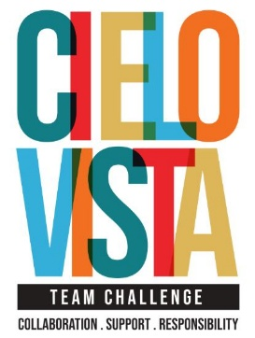
Is Cielo Vista Team Challenge Right for Your Team?
Take this quick quiz and find out!

📋 Check all that apply:
☐ We want to improve communication and collaboration
☐ We have team members of all ages and abilities
☐ We’re tired of boring offsite events with no impact
☐ We want a program that adapts to our needs—not the other way around
☐ Some of our team members are nervous about physical activity
☐ We value trust, respect, and emotional safety
☐ We want a location that’s easy to reach from San Antonio
☐ We’re looking for an inclusive experience where everyone plays a role
☐ We want real takeaways, not just fun
☐ We believe that strong teams make everything better

✅ Your Results:
- ✔️ 7 or more?
You’re our kind of team. Let’s make this happen!
🎯 Request a Quote
- ✔️ 4–6?
Sounds like we might be a great fit—let’s talk about your goals.
🎯 Contact Us
- ✔️ Less than 4?
We might not be what you're looking for right now—but keep us in mind!
Our programs are customizable, and we’re happy to answer any questions.

